

**Deep Learning for Perception Project**

**Celebrity Face Comparison and Matching**

**Course Instructor: Ms. Sumaiyah Zahid**

**Members:**

**Rimsha Nadeem (20K-1870)**

**Ayesha Nadeem (20K-1865)**

**Naima Jamal (20K-0404)**

**Objective:**

The objective of this project is to develop a system capable of accurately predicting which Bollywood celebrity a person resembles based on an uploaded image of their face. To achieve this, the project leverages deep learning techniques for facial recognition, including advanced face detection and feature extraction methods. By utilizing pre-trained convolutional neural network (CNN) models like ResNet-50 or VGGFace, the system extracts meaningful features from the facial images, capturing the unique characteristics of each face. These extracted features are then compared to the features of known Bollywood celebrities stored in the dataset, enabling the computation of a similarity score. Through this similarity comparison process, the system identifies the closest match or matches between the uploaded image and the celebrities in the dataset, providing users with an estimation of which Bollywood celebrity they resemble the most. Overall, the project aims to offer an engaging and accurate tool for users to discover their celebrity look-alike within the realm of Bollywood.

**Problem Statement:**

In an era where celebrities command significant public attention, there's a widespread desire among individuals to discern their resemblance to renowned figures. However, manual assessment of such resemblances is subjective and labor-intensive. Hence, our aim is to develop an automated system proficient in predicting which celebrity a person resembles based on an uploaded facial image. Leveraging deep learning methodologies encompassing face detection and feature extraction, the system will accurately isolate and identify faces within uploaded images.

With the rising prominence of social media and the entertainment sector, the identification and categorization of celebrity faces have emerged as crucial endeavors. Our project is motivated by the need to create a Celebrity Face Classifier model capable of precisely recognizing and categorizing faces of celebrities. Such a model holds potential utility across diverse applications, including security systems, recommendation engines, and social media surveillance.

**Methodology:**

Our Celebrity face classifier model utilizes the ResNet50 architecture for feature extraction and the MTCNN for face detection and alignment. The MTCNN is a CNN-based model that performs face detection and alignment using OpenCV's DNN module. The model uses the Max pooling technique and the PReLU activation function. The ResNet50 model consists of 176 layers and uses the ReLU activation function. We trained the model using the Softmax and Sigmoid activation functions.

1. **Data Collection and Preparation:**

The project is trained on 100 Bollywood celebrities and the dataset is taken from Kaggle: ‘Bollywood celeb localized face dataset’.

1. **Facial Detection and Feature Extraction:**

The MTCNN (Multi-Task Cascaded Convolutional Neural Network) is used for face detection. It's a popular deep learning model for detecting faces in images. The detected faces are then extracted from the original images. This step ensures that only the face region is used for further processing.

Pre-trained CNN models like ResNet-50 (pre-trained on ImageNet) or VGGFace are used for feature extraction to extract high-level features from the detected facial regions. Specifically, the output from the average pooling layer is used as a feature representation of the face. The features extracted from the face images serve as a numerical representation of the facial characteristics.

1. **Model Training:**

The ResNet-50 model is employed to extract features from the face images of Bollywood celebrities. These features are stored in a file (embeddings.pkl) for later use in similarity comparison.

1. **Model Testing:**

Once the model is trained, it is tested on new images. When a new image is uploaded, the MTCNN is used again to detect and extract the face from the image. The face image is then passed through the ResNet-50 model to extract its features. Cosine similarity is computed between the features of the uploaded image and the features of the celebrities in the dataset. The celebrity image with the highest similarity score is considered the predicted match.

**Results:**

1. **MTCNN and ResNet-50**

The results of the model showed medium to low accuracy, despite utilizing well equipped models such as ResNet-50. Throughout the implementation, there were recurring issues and errors that took lengthy periods of time to resolve, as well as high computational time that further elongated the training period.

Below is an example of uploaded image along with predicted image.

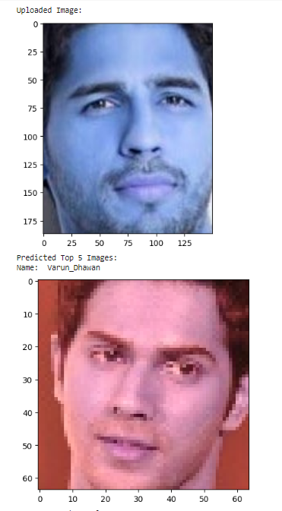

1. **VGG Face**

The result of the model showed high accuracy due the reason images from the already tested dataset have been used. Due to missing library keras.applications we were not able to integrate open source VGG Face Model hence we defined it. This is not preferable approach.

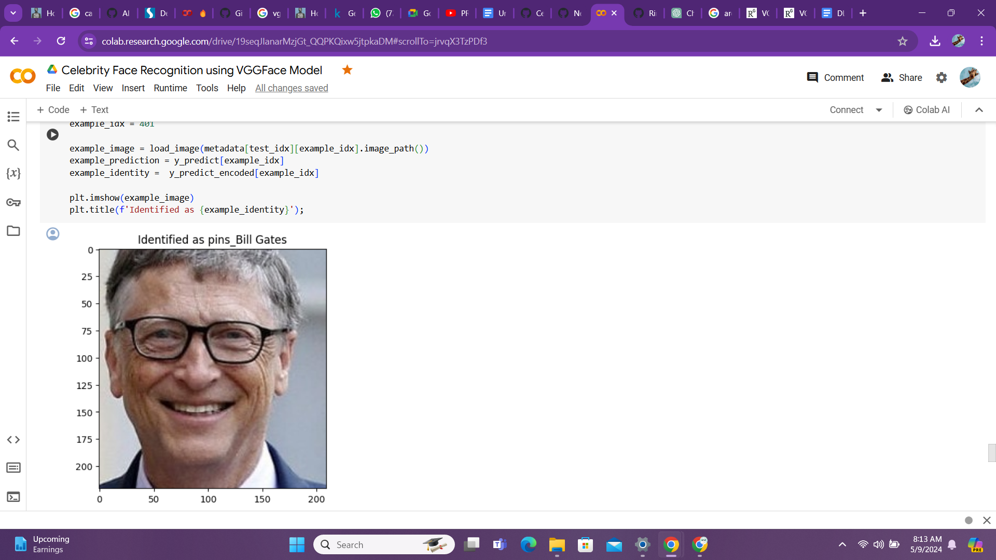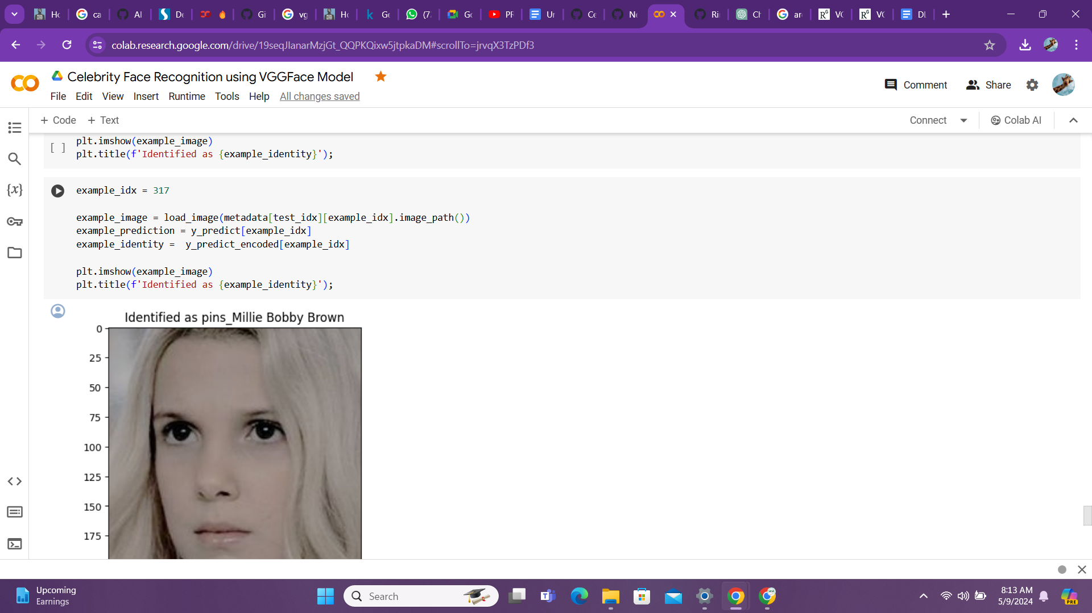

**References:**

<https://www.kaggle.com/datasets/sushilyadav1998/bollywood-celeb-localized-face-dataset>

<https://github.com/ipazc/mtcnn>